**Confusion matrix**

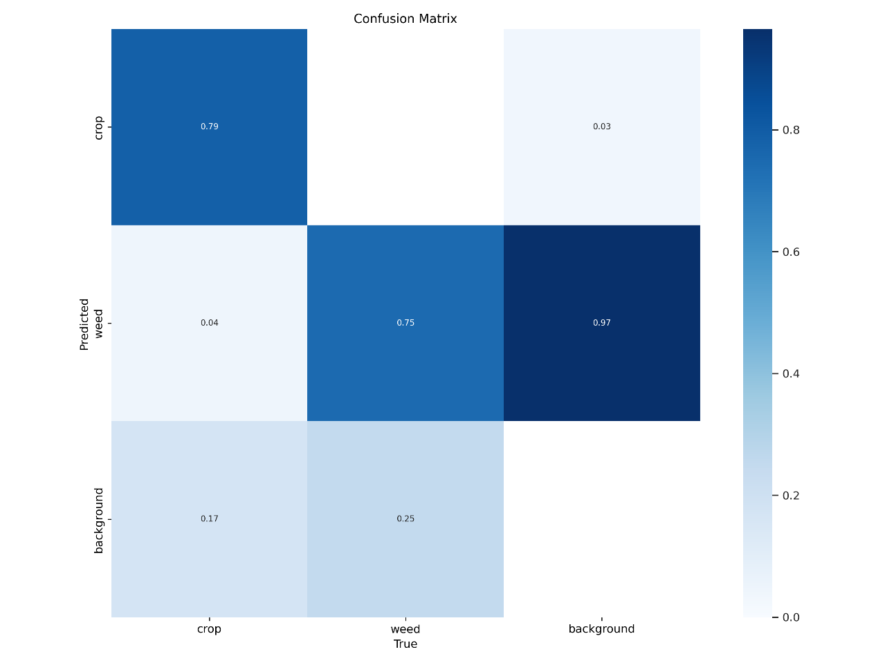

The given confusion matrix gives us insight into the accuracy practised by the Weed identification and classification model, as well as the areas of confusion across the three given categories that are: Crop, Weed and Background. The model correctly classified 79% of crops, with 4% of crops misclassified as weeds and 17% as background, showing that the model has a tendency to confuse the crops with the surroundings, which results in some of the crops being overlooked. Similarly for the weeds, 75% of them were accurately detected but as it is shown, there is still confusion between 3% of weeds classified as crops and 25% as background. This might reveal that the model deems it difficult to differentiate between weeds and non-relevant field elements, due to similarities in structure, texture, colour etc. The highest accuracy prediction was done of background elements with 97% correctly classified, whereas 3% we misidentified as crops and 25% were misidentified with weeds. This draws the conclusion that the model has considerable precision in background detection, but needs improvement in other classifications.

**Precision-Recall Curve**

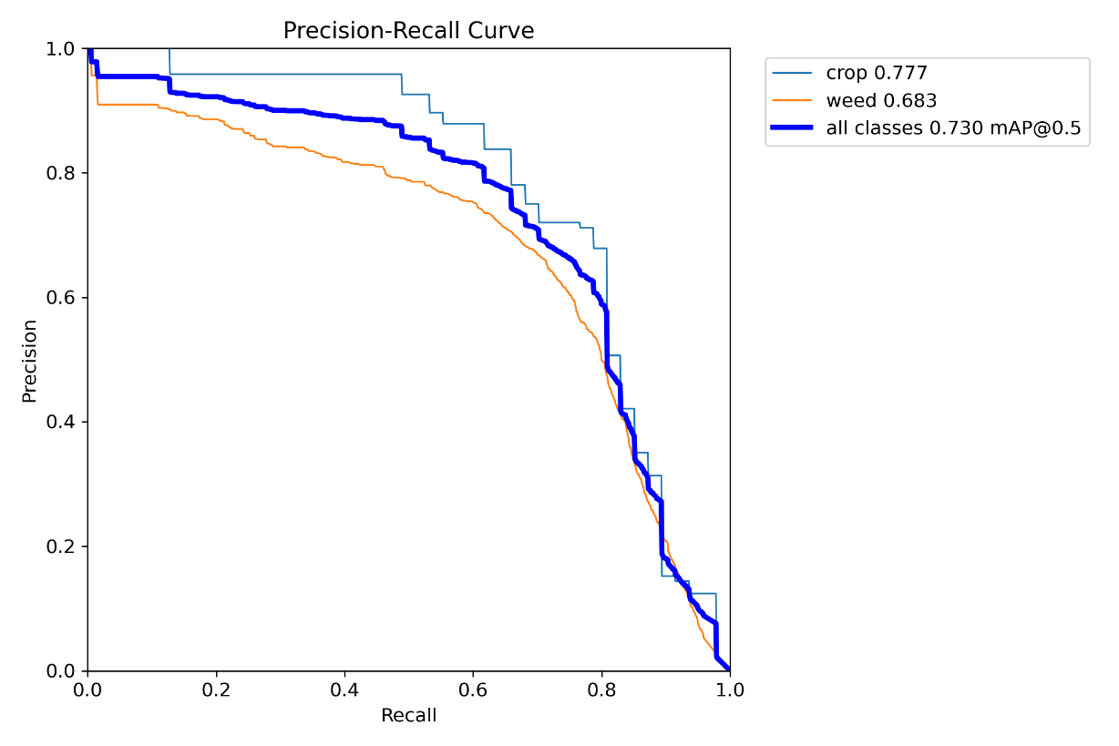

After analysing the Precision-Recall curve for the model, it is evident how good the model performs in identifying crops which is show by its high average precision(AP) of 0.77, but still lacks in weed detection accuracy where the AP is 0.683. The model struggles with differentiating between weeds and crop or other background elements, which results in reduced precision. The overall mean average precision (mAP) is 0.730 in all classes. This means that the model is generally reliable but still needs improvement, perhaps in weed detection. The conclusion to draw from this is that the model requires more refinement to make it more precise and reliable in the real world, increasing its effectiveness and subsequently its application in the agricultural field. Nonetheless it is still effective in crop identification and will do the job.